SMART NOTICE BOARD

Raghunatha Panda1, Sarthak Sarangi2, Saroj Kumar Pandit3

1, 2, 3UG Student, DRIEMS Autonomous Engineering College, Cuttack , Odisha

# ABSTRACT

Building an IoT based projects gives the fast transformation of knowledge and therefore the user can access the info from anywhere within the world. Notice board might be a primary consider any establishment or public places like bus stations, railway stations, colleges, malls etc. protruding numerous notices day to day may be a challenging method. A separate person is required to take care of this notice display. During this project, we've developed an IoT based smart board. The most objective of this project is develop an automatic ,self- enabled and highly reliable electronic bulletin board . A display connected with the cloud will continuously awaiting the message from the user, if the user upload the information within the Thing speak cloud, it'll automatically uploaded to the LCD. By using NodeMCU ESP8266, the user can upload the message to the LCD by accessing the Thing speak IoT cloud. The user can write the info from anywhere within the world to the LCD. This can reduce the time to update the information further because it will efficiently transfers the data’s to the top user. Entering the time of Internet of Things, the employment of small, shoddy and versatile constituent that allow end-user programming become present. One in all them, considered during this, is that the PIC microcontroller, fully customizable and programmable small computer board. Relative investigation of its key components and exhibitions with a number of current existing IOT prototype platforms have shown that despite few disadvantages, the PIC microcontroller remains an modest with its effectively utilization in diverse range of research applications in IOT vision.

**Keywords:** NodeMCU (ESP8266), LCD Display, Potentiometer, Breadboard, Pic Microcontroller

# INTRODUCTION

In moment’s world of connectedness, people are getting habituated to easy access to information. Whether it’s through the internet or TV, people want to be informed and over- to- date with the rearmost events passing around the world(J.S. Lee 2007). Wired network connection similar as Ethernet has numerous limitations depending on the need and type of connection. Now a day’s people prefer wireless connection because they can interact with people fluently and it bear lower time. The main ideal of this design is to develop a wireless notice board that display communication transferred from the stoner and to design a simple, easy to install, stoner friendly system, which can admit and display notice in a particular manner with respect to date and time which will help the stoner to fluently keep the track of notice board every day and each time he uses the system. Wi- Fi is the wireless technology used. This Document gives introductory preface to Digital signage which can operate using Wi- Fi. Now a day we've veritably lower option for advertising and it's veritably lengthy and boring process to announce and also we've veritably less effectiveness of that. So we've one

good option to reach over a people is Digital signage system. lately we've a digital signage but we've to change its content using USB drives or using internet when we're in the original or in wide area network. So this document gives us better idea how to change the contents of Digital display using Wi- Fi. So for that we use some Bedded as well as communication idea and using knot MCU we try to apply our system

# LITERATURE SURVEY

Bento, A. C et al. GSM Wireless Communication System [2010] : This paper mainly focuses on the application of GSM (Global System for Mobile communications). Advantages and Disadvantages of GSM has been marked here. GSM system is the most famous system for the Second Generation mobile telephony worldwide [1].

Ilha, P. et al. Display Message on Notice Board using GSM [2013]: This paper proposes the use of GSM technology for displaying notices on a digital notice board which helps to save time and energy. The notice board is eco-friendly and reduces the use of papers. Information can be given to a large mob in a very effective manner [2].

Kashyap, M. et al. Wireless Electronics Display Board Using GSM Technology [2013]: This paper explains a photo type laboratory model wireless notice board system. The board is connected with a GSM modem which enables the user to display the notice in public places using SMS [3].

Dalwadi, D et al. SMART NOTICE BOARD [2013] : This technical paper discusses on the present technology in association with daily life. It explains the importance of the Smart notice board and how efficiently it can be used in day to day life [4].

Ling, Z. et al. A Protocol for End-to-End Secure Transmission of SMS [2014] : In this paper the Easy SMS protocol and how it can be successfully designed so as to provide end to end secure communication through SMS is discussed. The analysis shows the focus on security and methods to prevent various attacks. Also it explains the other aspects like communication, bandwidth etc [5].

# PROPOSED MODEL

The following sub-sections represents the different components associated with the proposed model.

## COMPONENTS

In this design, the entire model is grounded on the NodeMCU with each element placed strictly on the breadboard. NodeMCU is chosen because of its main parcels ideal for this design-simple, low cost and programmable. Its work analogous to Arduino and also is Wi- Fi enabled which is stylish for IoT operation process. I2C appendage is needed to connect NodeMCU with the TV display. NodeMCU uses 4 legs to connect with display. We're using 16x2 TV to display the notice. The introductory TV requires 3 control lines as well as 4 or 8 I/ O lines for the data machine. The stoner may elect whether the TV is to operate with a 4- bit

data machine or an 8- bit data machine. This TV is sufficient to display. But we can connect JUMBO TV also. A buzzer is used to notify the stoner whether notice is transferred to display or not.Fig. 1 shows the block illustration for this model

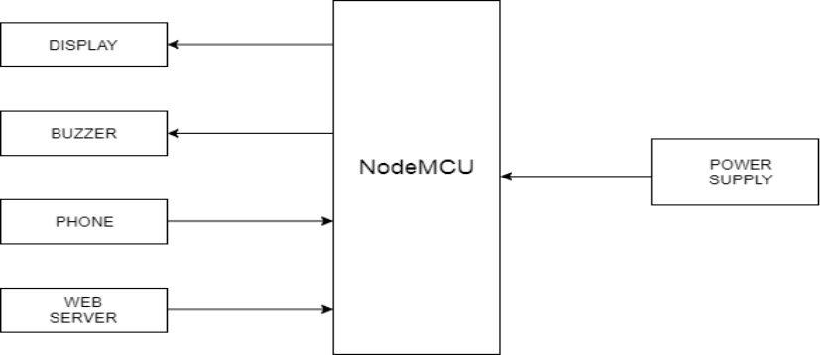

**Fig. 1.** Block Diagram of Proposed Architecture

## CIRCUIT DETAILS

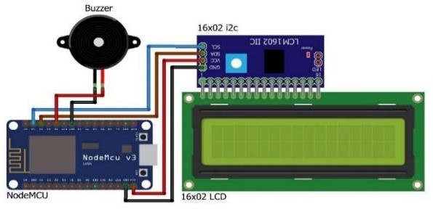A simple block model has been used in the design. In this model, we've to connect the NodeMCU with a power force. This power can be supplied by any power sources. After connecting the NodeMCU with the power force, NodeMCU will show a communication that input an IP addresses. To input an IP address, we've to connect the NodeMCU with a hotspot. After connecting the NodeMCU with the hotspot there will be an IP address webbing on the NodeMCU.Fig. 2 shows the circuit illustration for this model.

**Fig. 2.** Circuit Diagram of Proposed Architecture

## WORKING PRINCIPLE

Originally, initializing the NodeMCU as well as webserver and app by supplying power the display will show an unset IP address. By creating a particular hotspot, the NodeMCU will admit the established connection and showing an IP address in the display. still, frequently using multiple access from different persons from different connection of phones, laptops and other bias this must be connected to same particular hotspot to show the convey communication. After doing this, there's also an app that's used for making the connection between a NodeMCU and a phone. After connecting the phone with the following IP address, phone will be directly connected to the android app. By using this android app, we can write a notice and it'll directly go to the NodeMCU. Whenever NodeMCU admit a notice, the buzzer will give a beep sound and notice communication will be shown in the display. If there's a problem between connecting an android and following ip address which means no matching for both IP address showing in the NodeMCU and the app the communication won't be shown in the display. In that case, the procedure must be renewed to assemble the whole process to work again with principles as well.Fig. 3 shows the working principle for this model.

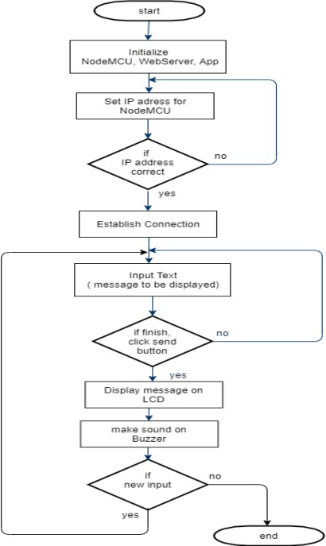

**Fig. 3.** Flowchart of Proposed Model

# EXPERIMENTAL SETUP AND RESULT ANALYSIS

In this design we're going to shoot the data in the 16x02 TV Display without using any line. The list of the factors is NodeMCU esp8266, I2C appendage for 16x02 TV Display, 16x02 TV Display, Mini Breadboard, Jumper Cables, PVC Board, Buzzer( 5)( 6). NodeMCU esp8266 Wi- Fi model it works as a garçon in this design. By using its motorist harbourage 16x02 TV Display shows the data has transferred. originally, we set the GND of I2C appendage to GND of NodeMCU esp8266. After that we set the VCC of I2C appendage to Vin of NodeMCU esp8266. also the SDA of I2C Adapter set to D2 of NodeMCU esp8266 and SCL of I2C appendage set to D1 of NodeMCU esp8266. Another GND and D4 of NodeMCU esp8266 set to Buzzer. Incipiently, we've to connect 1- 16 leg of I2C appendage with 16x02 TV Display. The model is now able of display any notice through the proper use and changes in law and operation. Fig. 4 shows some sample of the experimental circuit setup and the final device of this model.

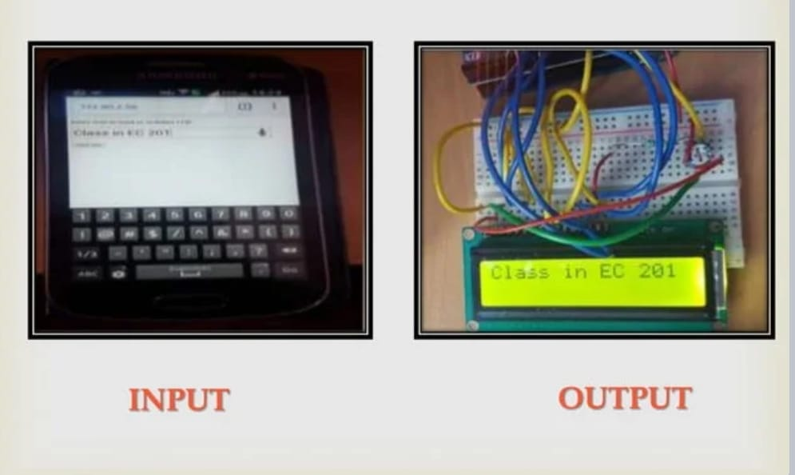

**Fig. 4.** Final device

# CONCLUSION

In this ultramodern period of technology is helping us to reduce mortal work. The proposed design can drop work cargo and mortal reliance. It's proposed to design display toolkit which can be used from an authorized app. The display boards are one of the most important media for transferring information to the maximum number of end druggies. With the advancement in technology the display board systems are migrating from normal hand- written display to digital display. A stoner can shoot a communication from anywhere in the world. Being stoner friendly, long range and speedy mean of conveying information are major characteristics of this system

# REFERENCES

1.Dharmendra Kumar Sharma and Vineet Tiwari, Small and me- dium range wireless electronic notice board using Bluetooth and ZigBee IEEE 2015.

2.Neeraj Khera and Divya Shukla Development of simple and low cost Android based wireless notice board IEEE 2016.

3.Aniket Pramanik, Rishikesh and Vikash Nagar GSM based Smart home and digital notice board IEEE 2016.

4.Kruthika Simha, Shreya and Chethan Kumar Electronic notice board with multiple output display IEEE 2017

5.S. Rubin Bose and J. Jasper Prem Design and Implementation of Digital Notice Board Using IoT IJRIER 2017

6.Meenachi, A., Kowsalya, S., & Kumar, P. P. (2016). Wireless E-Notice board using wi-fi and bluetooth technology. Journal of Network Communications and Emerging Technologies (JNCET),